Friday, September 19th, 8.30 a.m., Room B:
Melting, melt treatment
8.30 – 8.50: B. Košec*, M. Trbižan**; *Valji d.o.o. Štore, **University of Ljubljana: Improving of the indefinite chill rollls casting technology with oxygen activity measurement and thermal analysis
8.50 – 9.10: M. Škrbec, J. Koleša; Livar d.d.: Identification and prevention of porosity defects in grey and ductile iron castings from mold metal interface reactions
9.10 – 9.30: N. Child; Foseco GmbH (D): Modern technology for ladle linings in iron foundries
9.30 – 9.50: F. Donsbach, E. Neumann; Otto Junker GmbH (D): Solution of specific technological and metallurgical requirements in medium-frequency melting furnaces
9.50 – 10.10: S. Olsen; Elkem (NO): Recovery of magnesium in a ductile iron process
10.10 – 10.30: Break
10.30 - 10.50: J. Soudier; Lafarge Refractories (F): Easy casting with new generation of refractory castables
Iron alloys
10.50 – 11.10: V. Dunat, L. Gajić; Litostroj Ulitki d.o.o.: Influence of wall thickness on ferrite – austenite ration in duplex stainless steel
11.10 – 11.30: S. Schwenkel, R. Döpp; TU Clausthal (D): Investigation of eutectic solidification range of Fe-C-X melts, a key to graphitisation
11.30 – 11.50: J. Medved*, P. Mrvar*, S. Ihanec**, V.Gontarev*; *University of Ljubljana, **Eti Izlake: Reaction between the foam filter and molten metal
11.50 – 12.10: P. Mrvar, M. Trbižan, J. Medved; University of Ljubljana: Influence of the cooling rate and alloying elements on the eutectoid transformation in SGI
12.10 – 12.30: Break
12.30 – 12.50: H. Rödter; RTIron & Titanium GmbH (D): Influences effecting and improving machinability of ductile iron castings
12.50 – 1.10: P. Gostiša*, B. Saje*, L. Gajić**; *Magneti d.d., **Litostroj Ulitki d.o.o.: Use of recycled materials for AlNiCo alloys
1.10 – 1.30: I. Surina; TDR Metalurgija d.d.: Consumption trend of FeSiMg alloys
Friday, September 19th, 2.00 p.m.: Closing reception

Informations:
Društvo livarjev Slovenije
Lepi pot 6, P.B. 424
SI – 1001 Ljubljana
Slovenia

Phone/Fax: +386 1 2522 488
E-mail: drustvo.livarjev@siol.net
Web side:
www.uni-lj.si/societies/foundry

Contact person:
Dipl. Eng. Katarina Trbižan
Phone: +386 1 2000 428
E-mail: katarina.trbizan@uni-lj.si

Slovenian Foundrymen`s Society 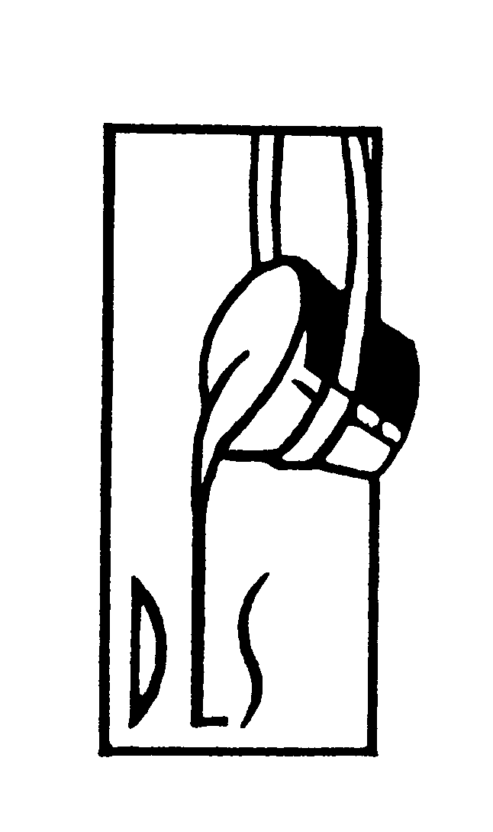

43rd Foundry Conference

with 50th Anniversary
of Društvo livarjev Slovenije
and Livarski vestnik

September 18th - 19th, 2003

Convention Center in Hotel Slovenija

Portorož, Slovenia

PROGRAMME

Wednesday, September 17th, 2.00 p.m.:
10th Meeting of WFO International Commission 3.3: »Computer Simulation of Casting Processes«

Wednesday, September 17th, 8.30 p.m.:
Reception by Mayoress of Community Piran
prof. Vojka Štular

Thursday, September 18th, 9.30 a.m.:
9.30 – 10.10: M. Trbižan; University of Ljubljana:
Greetings and opening
50 years of Slovenian Foundrymen`s Society
Awarding of acknowledgments
Plenar papers:
10.10 – 10.30: G. Engels; Düsseldorf (D): Half a century of foundry technical progress in the mirror of GIFA
10.30 – 10.50: J. Tybulczuk; Foundry Institute Krakow (PL): Modern materials for castings – a driving factor in innovation of final products
10.50 – 11.10 a.m.: Break
11.10 – 11.30: T. Schmidt, E.d. Maire; Heidenreich & Harbeck AG (D): New methods for the systematic design - optimization of large cast parts
11.30 – 11.50: K. Urbat; CAEF (EU): Economy status of European foundry industry
11.50 – 12.00: T. Elbel*, M. Horaček**; *TU Ostrava, **TU Brno (CZ): Prospects of foundrymen cooperation in EU – candidate countries on solving main problems in foundry industry
12.00 – 12.20: G. Steffenato; ASSOFOND (I): Outlook of Italian foundries 2002 / 2003
12.20 – 12.30: F. Unkić; University of Zagreb (CRO): Characteristics of casting production in Croatia

12.30 – 2.10 p.m.: Break
Thursday, September 18th, 2.10 p.m.:
Foundry technology
2.10 – 2.30: A. Wilcox; SLS Engineering AG (CH): How to increase productivity and decrease costs of foundry processes by more than 30%
2.30 – 2.50: D. Zadnek, J. Čevka, B. Veber; Exoterm-IT d.o.o.: Representation of technological novelty – dust mixtures production
2.50 – 3.10: A. Sešek Pavlin, G. Pavlin; Termit d.d. Domžale: Use of quality tools in the production of coated sands and cores
3.10 – 3.30: G. Müller-Späth; GUT GmbH (D): MyLOGI – Information management for mechanized no-bake moulding lines
3.30 – 3.50: N.W. Rasmussen; DISA Industries A/S (DK): Process development for production of castings in iron and aluminium
3.50 – 4.10: J. Pristavec*, B. Metelko**, M. Škrbec**, F. Kogovšek***; *Exoterm-IT d.o.o., **Livar d.d., *** Inženiring kakovosti d.o.o.: Finding control parameter values that ensure a robustness of the casting process
4.10 – 4.30: Break
4.30 – 4.50: A. Mikuž, M. Gnamuš; Litostroj Ulitki d.o.o.: Application of Six Sigma methods for improvements of foundry process
4.50 – 5.10: D. Hareaux, M. Planinšič; Abrasiv Muta d.o.o.: Optimization of blasting costs in foundries
5.10 – 5.30: E. Eržen*, I. Jurkošek**, I. Oto***, M. Trbižan****; *Fenolit d.d., **Termit d.d. Domžale, *** Croning livarna d.o.o., ****University of Ljubljana: Shell moulds deformability by steel casting
5.30 – 5.50: M. Augustin; Moravske keramicke zavody a.s. (CZ): The presentation of MKZ
5.50 – 6.10: R. Rudolf, I. Anžel, A. Križman; University of Maribor: The analysis of the high carbon steel shot defects

Thursday, September 18th, 7.00 p.m.:
Watertour Portorož-Trst-Portorož with Fishdinner by boat BURJA anchored by the main pier in Portorož
Friday, September 19th, 8.30 a.m., Room A:
Nonferrous alloys
8.30 – 8.50: P. Schumacher, ÖGI Leoben (A): Grain refining of AlSi alloys
8.50 – 9.10: G. Lojen, I. Anžel, A. Križman; University of Maribor: Physical model of simultaneous dissolution of α Al and solid Si in AlSi-melt
9.10 – 9.30: R. Klos, H. Koch; Aluminium Rheinfelden GmbH (D): Silafont®-36, the first low iron die casting alloy, -properties and applications-
9.30 – 9.50: A. Kraly, G. Trenda, F. Brandl; Aluminium Lend GmbH (A): Recent developments in premium diecasting alloys
9.50 – 10.10: A. Megušar, G. Podlipnik; TCG Unitech Lth-ol d.o.o.: Strength characteristics improvement of AL-castings with part design and process optimisation
10.10 – 10.30 a.m.: Break
10.30 – 10.50: F. Klein; FH Aalen (D): Cost reduction producing pressure die casting
10.50 – 11.10: A. Križman, M. Brunčko, I. Anžel; University of Maribor: Characterization of directional solidification with application of ERT measurement technique
11.10 – 11.30: K. Weiss; RWP GmbH (D): Latest research on applications of metallic and alloyed material
11.30 – 11.50: G. Schindelbacher, T. Pabel; ÖGI Leoben (A): Effects of hipping and chilling to the mechanical properties of Al-alloys
11.50 – 12.10: R. Koren, K. Juvan; ABB d.o.o.: Automation of pressure die casting with robots
12.10 – 12.30 p.m.: Break
12.30 – 12.50: A. Klemenčič; Mariborska livarna d.d.: The use of the oxygen burner for melting copper alloys in the rotary melting furnace
12.50 – 1.10: B. Kožuh; Talum d.d.: Casthouse modernisation in Talum
1.10 – 1.30: Z. Zovko Brodarac*, M. Trbižan**, F. Unkić*; *University of Zagreb (CRO), **University of Ljubljana: Study of shrinkage occurance in AlSi9Cu3 high pressure die casting
Friday, September 19th, 2.00 p.m.: Closing reception

