43rd Foundry Conference, Portorož, Slovenia
18th – 19th September 2003

PARTICIPATION POSSIBILITIES
PARTICIPATION FEE | 175 EUR
COMPANION (Ladies): | 70 EUR
EXHIBITION includes:  - free place on exhibition (1 panel*, 1 table, chairs)  - one person free of participation fee (exhibition person) | 350 EUR
SPONSORSHIP includes:  - free place on exhibition (2 panels*, 2 tables, chairs)  - two persons free of participation fee (lecturer + exhibition person)  - free publishing of advertisement in conference book (1 A4 page)  - paper presentation (15 minutes) with technical contents  - all papers will be published on the CD - rom and abstracts in conference book in two languages (english and slovenian)  - sponsors organize for all participants water-tour Portorož-Trieste-Portorož with fish-dinner (special invitation with named sponsors) | 700 EUR
*Panel 100 x 125 cm
Participation includes conference material and social program.

EXHIBITION PLACES - Reservations:

A and B: sponsors; C and D: exhibitors
Sponsors:  A1 – SRI, Livarski inženiring (SI)  A2 – Thermobiel Apparatebau GmbH (D)  A3 – OTTO JUNKER GmbH (D)  A4 - LABOR AS d.o.o. (SI)  A5 – EXOTERM-IT (SI)  A6 – GUT GmbH (D)  A7 – DRACHE Diez (D)  B1 – KREMEN Novo Mesto d.d. (SI)  B2 – ATHLETICON GmbH (A)  B3 – TDR Metalurgija d.d. (SI)  B4 – Lafarge Refractories GmbH (A)  B5 – FOSECO GmbH (D)  B6 - Moravske Keramicke Zavody a.s. (CZ)  B7 – TERMIT Domžale (SI)  C4 – SLS Engineering AG (CH)  C8 – RWP GmbH (D)  C9 – ELKEM Oslo (NO)  D9 – ABB d.o.o. (SI)  Exhibitors:  D4 – ETI d.d. Izlake (SI)  D5 – SWATY d.d. (SI)  D6 – VESUVIUS (D) |  | 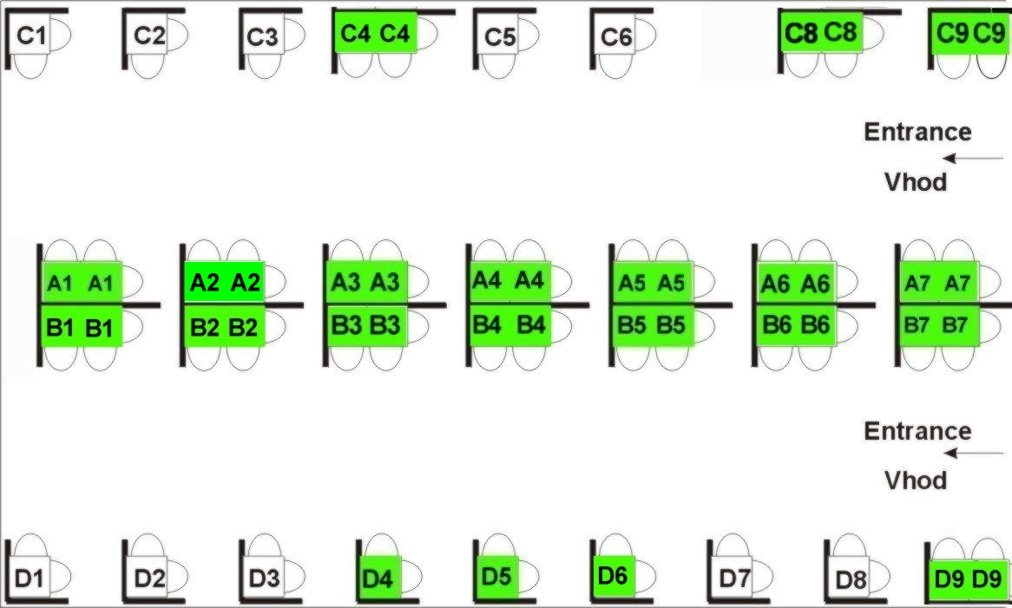

--------------------------------------------------------------------------------------------------------------------

APPLICATION FORM
for 43rd Foundry Conference, September 18th - 19th, 2003 in Portorož, Slovenia

Send till September 10th, 2003 on address: Društvo livarjev Slovenije, Lepi pot 6, P.B. 424, SI–1001 Ljubljana
Phone / Fax: +386 1 2522 488, E-mail: katarina.trbizan@uni-lj.si
Title, name and surname:
Companion:
Company and adress:
Phone: |  |  |  |  |  | Fax: |  |  |  |  | E-mail:
Date: |  |  |  |  |  | Signature:
Mark type of participation: |  |  |  |  |  |  |  |  | Reservation of exhibition place:
◻ | Participation |  | ◻ |  | Sponsorship - Place Nr. _____or:_____ |  |  |  |  |  |  | ◻ | Exhibition - Place Nr. _____or:_____
Total amount:

To pay on account: 02010-0013289645, SWIFT: LJBASI2X, Nova Ljubljanska banka d.d., Ljubljana
Confirmation of money order bring with you.

ACCOMMODATIONS IN PORTOROŽ

SPECIAL ATTENTION:

Hoteli Morje reserved for Društvo livarjev Slovenije enough rooms for participants, but because of high occupation only till Friday, August 1st 2003!

Reservations are possible also in other hotels, but only till they are full, so hurry up with reservations!

 | Hotel | Room (price per person) |  | Informations and reservations
 |  | 1/1 | 1/2
 | Hoteli Morje
 | Attention: Reservations till August 1st 2003! |  |  | Mrs. Ljiljana Terzič
**** | Hotel Slovenija | 111 EUR | 74 EUR | Internet: | www.hoteli-morje.si
**** | Hotel Riviera | 111 EUR | 74 EUR | E-mail: | booking@hoteli-morje.si
 |  |  |  | Phone: | ++386 5 692 3333
 |  |  |  | Fax: | ++386 5 692 3180
 | Metropol Group
 |  |  |  | Mr. Marko Ferluga
***** | Hotel Metropol | 91 EUR | 70 EUR | Internet: | www.metropolgroup.si
**** | Hotel Roža | / | 46 EUR | E-mail: | marko@metropolgroup.si
*** | Hotel Lucija | / | 33 EUR | Phone: | ++386 5 690 7000
*** | Hotel Barbara | / | 33 EUR | Fax: | ++386 5 690 7877
*** | Villas Senegačnik | 33 EUR | 40 EUR | Mr. Silvester Senegačnik
 | (sea view) |  | 51 EUR | Address: | Stara cesta 11-13, SI-6320 Portorož
 |  |  | (per room) | Phone: | ++386 5 674 4300
 |  |  |  | Fax: | ++386 5 674 4300
 | Pensions |  |  | Tourist servis Portorož
 | (without breakfast) |  |  | Address: | Postajališka 2, SI-6320 Portorož
*** |  | 19 EUR | 30 EUR | Internet: | www.tourist-portoroz-sp.si
** |  | 16 EUR | 25 EUR | E-mail: | tourist-portoroz@siol.net
* |  | 15 EUR | 22 EUR | Phone: | ++386 5 674 0360
 |  |  | (per room) | Fax: | ++386 5 674 0361

Turist tax: 0,8 EUR / person and day 1 EUR ~ 231 SIT

--------------------------------------------------------------------------------------------------------------------
Slovenian Foundrymen`s Society will control hotel reservations and confirmations, so we ask you to send a copy of reservation form also to Društvo livarjev Slovenije, P.B. 424, Lepi pot 6, SI–1001 Ljubljana, Slovenia
Fax: +386 1 2522 488, E-mail: katarina.trbizan@uni-lj.si

RESERVATION FORM FOR THE ACCOMMODATION
for 43rd Foundry Conference, September 18th - 19th, 2003 in Portorož, Slovenia
Title, name and surname:
Company:
Address:
Phone: |  |  |  |  | Fax: |  |  |  | E-mail:
I would like to reserve: |  |  |  |  |  |  |  | room in Hotel:
Arrival date: |  |  |  |  |  |  | Departure date:
Date: |  |  |  |  |  | Signature:

Confirmation of reservation send on upper address!

