CALL FOR PARTICIPATION
43rd Foundry Conference
with 50 th Anniversary of Društvo livarjev Slovenije and Livarski vestnik
September 18th - 19th, 2003

in new CONVENTION CENTER IN HOTEL SLOVENIJA, Portorož, Slovenia

PRELIMINARY PROGRAMME

Wednesday,  September 17th | afternoon:  evening: | 10 th Meeting of WFO International Commission 3.3  Reception by Mayoress of Community Piran prof. Vojka Štular
Thursday,  September 18th | morning:  afternoon:  evening: | Greetings and opening, awarding of aknowledgments, plenar papers  Technical papers  Watertour Portorož-Trst-Portorož with Fishdinner
Friday,  September 19th | morning A:  afternoon A:  morning B:  afternoon B: | Technical papers  Technical papers  Technical papers  Technical papers

--------------------------------------------------------------------------------------------------------------------

APPLICATION FORM
for 43rd Foundry Conference, September 18th - 19th, 2003 in Portorož, Slovenia
Title, name and surname:
Company and adress:
Phone: |  |  |  | Fax: |  |  |  |  | E-mail:
Date: |  |  |  | Signature:
Mark type of participation: |  |  |  |  |  |  | Reservation of exhibition place: (TURN!)
◻ | Participation |  |  |  | ◻ |  | Sponsorship (A in B)* |  |  | ◻ |  | Exhibition (C in D)*
◻ | Lecturer (free of participation fee) |  |  |  |  |  | Place Nr. _____ or: ______ |  |  |  |  | Place Nr. _____ or: ______
*Reservations are written in Home page of Slovenian Foundrymen`s Society: www.uni-lj.si/societies/foundry
Send till September 10th, 2003 on address: Društvo livarjev Slovenije, Lepi pot 6, P.B. 424, SI–1001 Ljubljana
Phone / Fax: +386 1 2522 488, E-mail: katarina.trbizan@uni-lj.si

PARTICIPATION POSSIBILITIES

PARTICIPATION FEE | 175 EUR
COMPANION (Ladies): | 70 EUR
EXHIBITION includes:  - free place on exhibition (1 panel*, 1 table, chairs)  - one person free of participation fee (exhibition person) | 350 EUR
SPONSORSHIP includes:  - free place on exhibition (2 panels*, 2 tables, chairs)  - two persons free of participation fee (lecturer + exhibition person)  - free publishing of advertisement in conference book (1 A4 page)  - paper presentation (15 minutes) with technical contents  - all papers will be published on the CD - rom and abstracts in conference book in two languages (english and slovenian)  - sponsors organize for all participants water-tour Portorož-Trieste-Portorož with fish-dinner (special invitation with named sponsors) | 700 EUR

*Panel 100 x 125 cm
Participation includes conference material and social program.

EXHIBITION PLACES

A and B: sponsors; C and D: exhibitors

Reservations:
Sponsors:  A1 – SRI, Livarski inženiring (SI)  A3 – OTTO JUNKER GmbH (D)  A4 - LABOR AS d.o.o. (SI)  A5 – EXOTERM-IT (SI)  A7 – DRACHE Diez (D)  B5 – FOSECO GmbH (D)  B7 – TERMIT Domžale (SI) |  | Exhibitors:  D4 – ETI d.d. Izlake (SI)  D5 – SWATY d.d. (SI)
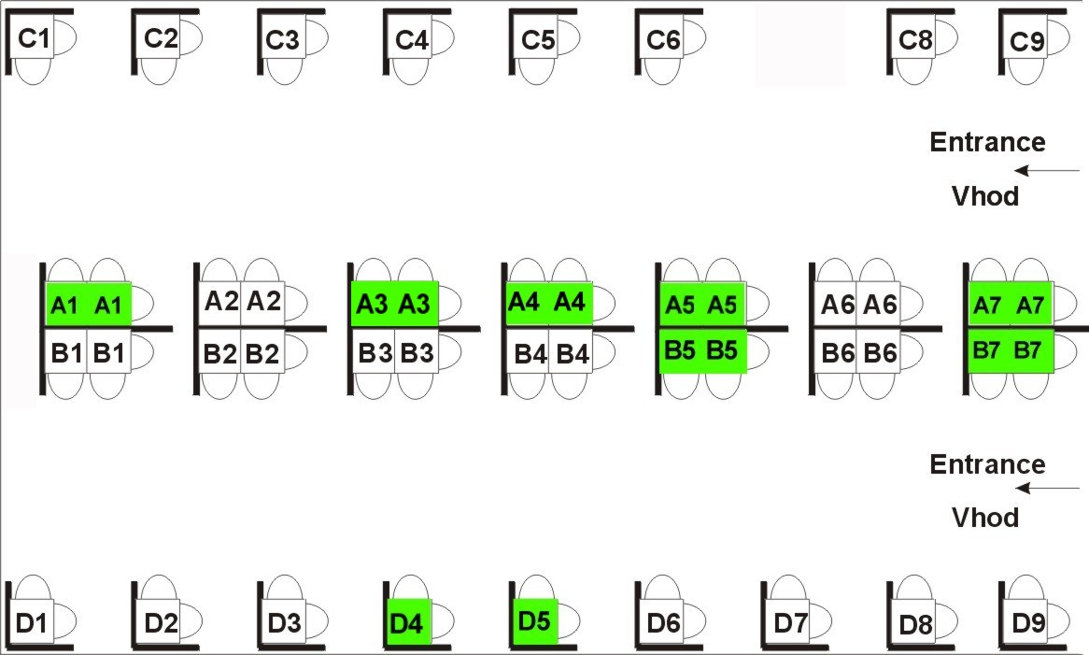

ACCOMMODATIONS IN PORTOROŽ

SPECIAL ATTENTION:

Hoteli Morje reserved for Društvo livarjev Slovenije enough rooms for participants, but because of high occupation only till Friday, August 1st 2003!

Reservations are possible also in other hotels, but only till they are full, so hurry up with reservations!

 | Hotel | Room (price per person) |  | Informations and reservations
 |  | 1/1 | 1/2
 | Hoteli Morje
 | Attention: Reservations till August 1st 2003! |  |  | Mr. Mario Belac
**** | Hotel Slovenija | 111 EUR | 74 EUR | Internet: | www.hoteli-morje.si
**** | Hotel Riviera | 111 EUR | 74 EUR | E-mail: | booking@hoteli-morje.si
 |  |  |  | Phone: | ++386 5 692 3333
 |  |  |  | Fax: | ++386 5 692 3180
 | Metropol Group
 |  |  |  | Mr. Marko Ferluga
***** | Hotel Metropol | 91 EUR | 70 EUR | Internet: | www.metropolgroup.si
**** | Hotel Roža | / | 46 EUR | E-mail: | marko@metropolgroup.si
*** | Hotel Lucija | / | 33 EUR | Phone: | ++386 5 690 7000
*** | Hotel Barbara | / | 33 EUR | Fax: | ++386 5 690 7877
*** | Villas Senegačnik | 33 EUR | 40 EUR | Mr. Silvester Senegačnik
 | (sea view) |  | 51 EUR | Address: | Stara cesta 11-13, SI-6320 Portorož
 |  |  | (per room) | Phone: | ++386 5 674 4300
 |  |  |  | Fax: | ++386 5 674 4300
 | Pensions |  |  | Tourist servis Portorož
 | (without breakfast) |  |  | Address: | Postajališka 2, SI-6320 Portorož
*** |  | 19 EUR | 30 EUR | Internet: | www.tourist-portoroz-sp.si
** |  | 16 EUR | 25 EUR | E-mail: | tourist-portoroz@siol.net
* |  | 15 EUR | 22 EUR | Phone: | ++386 5 674 0360
 |  |  | (per room) | Fax: | ++386 5 674 0361

Turist tax: 0,8 EUR / person and day 1 EUR ~ 231 SIT

--------------------------------------------------------------------------------------------------------------------

RESERVATION FORM FOR THE ACCOMMODATION
for 43rd Foundry Conference, September 18th - 19th, 2003 in Portorož, Slovenia

Title, name and surname:
Company:
Address:
Phone: |  |  |  |  | Fax: |  |  |  | E-mail:
I would like to reserve: |  |  |  |  |  |  |  | room in Hotel:
Arrival date: |  |  |  |  |  |  | Departure date:
Date: |  |  |  |  |  | Signature:

Confirmation send on upper address!

50 th Anniversary
of Društvo livarjev Slovenije
and Livarski vestnik
(1953 – 2003)

- Founding general meeting of Društvo livarjev Slovenije on June 27 th, 1953

- Basic aims:
  - Connection and experience exchange between foundrymen through conferences, lectures, excursions, workshops etc. for development of foundry cadres
  - Binding all, which work in foundry branche or cooperate with them, without regard to education level, from beginners to top-level experts and scientist
  - Development of foundry technology and foundry metallurgy
  - Development of foundry mechanisation
  - Development of foundry raw materials, binders, coatings, refractory materials and equipment

- Performed work in 50 years:
  - 42 foundry conferences
  - 34 bigger technical excursions abroad
  - 181 seminars
  - over 100 workshops and films
  - regulary publishing of Livarski vestnik, 296 regular issues with 9.600 pages
  - 14 special issues of Livarski vestnik
  - 5 monographs
  - 73 duplicated materials of seminars

- The President of the Republic of Slovenia has confered on
Društvo livarjev Slovenije
The Order of Freedom of the Republic of Slovenia
in recognition of its contribution to technical
and economic development of foundry industry of Slovenia

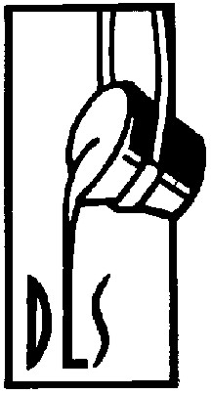 |  | 