 | DEADLINES  Abstracts: April 23rd, 2002  Full papers: July 29th, 2002  Early Registration: October 2nd, 2002  Author’s special registration fee $ 170  (only one author per paper)  LANGUAGE  Abstract and papers can be written and presented in English, Spanish and Portuguese. Simultaneous translation will be available.  PROCEEDINGS  A CD/ROM and/or a book with all the full papers will be available during the conference.  ADDITIONAL INFORMATION  To obtain more information on this event, please contact  Cristian Genzano  Instituto Argentino de Siderurgia  Av. Central y Calle 19 Oeste  2900 San Nicolás, Pcia. de Buenos Aires  República Argentina  Tel. 54 3461 460803  Fax. 54 3461 462989  e-mail: genzano.ias@cablenet.com.ar | 14th Rolling Conference  1st Conference on Uses of Steel  Sheraton Hotel, Buenos Aires  November 5 – 7, 2002  To the Organizing Committee  I submit the following paper:  Title:………………..…………………………..……………….………………….…………….…………...……………….…………………….…..……………………………………………………….………………….…………………………………………………………………………….…...  ……………………………………………………………………………..  Authors:……………………….….………………….…………………………………...…..……………………………………….…………...…………..…………………….……………………...…………………..….…..……………………………..………………….……………………………………………………………………………………………………...…..  ……………………………………………….………………...…………..  Company:……………………….…….……………..………………………………...………….…………………..…………………………...…………………………………..…………………………………………………………………………………………………………….………….......  ……………………………………………..….…………………………...  Address:………………….………………….……………………………….……………………………………………………..…………………………………………………………..………………………………………  City:………………………….……...….…………..……………………  State:…………………………………………….………………………...  ZIP:………………………………………….…………….………….  ……………………………………………………………….……………..  Country:……………………………………………..…….……………..  Phone:……………………………….……………….……….………  e-mail:…………………………………..…………….………………….  ……………………………………..………………………………..……..  ……………………………………………...………..….……..  Abstracts can be send on-line in the URL www.cablenet.com.ar/ias/semlaminacioneng.htm |  | 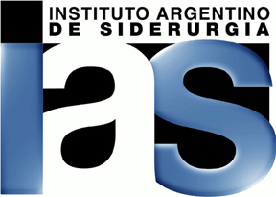  First Announcement and  Call for Papers  14th Rolling Conference  1st Conference on Uses of Steel  4th ISS Argentina Section Meeting  Suppliers Exhibit  Steel Products Exhibit  November 5 – 7, 2002  Hotel Sheraton, Buenos Aires
Organized conjoinctly with  Encouraged by the outstanding success of previous events organized by the IAS in the latest years, the Board of Directors decided to relance the Rolling Conference and to organize by the first time a Conference on Uses of Steel.  This way, an occasion for interchange of experience and knowledge between Latin American rollers and world specialists is reopened. And a new r different part of the world is possible. Also a new forum for information on the large field of steel utilization is launched.  The 14th Rolling Conference includes a Course by Professor Anthony J. DeArdo, University of Pittsburgh, as well as Technical Sessions on issues interesting for both long and flat products people, rolling mill tours and social events.  The 1st Conference on Uses of Steel includes a group of Technical Sessions oriented to specific steel uses and other group of sessions focused on the final processing of the steel.  Simultaneously, the 4th ISS Argentina Section Meeting will take place, as well as an exhibit oriented by the one hand to suppliers of technology and equipment for rolling mills, and by the other hand to manufacturers of steel products.  We invite the industrial and academic world to present papers. We invite suppliers and manufacturers to sponsor the event and/or having a booth in the exhibit.  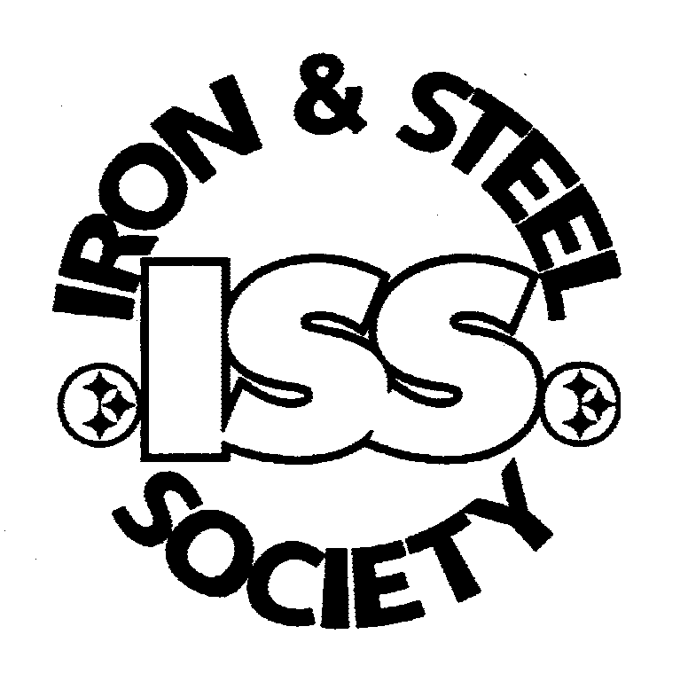  Argentina Section |  |  | 14th ROLLING CONFERENCE PROGRAM  November 5th, 2002  Course on Alloy Design and Hot Rolling of Steels for the 21st Century, by Professor Anthony J. DeArdo  (University of Pittsburgh, U.S.A.)  November 6th, 2002  Opening of the Conference and Exhibit  Technical Sessions on  - Physical Metallurgy of Steel  - Mechanical Properties of Steel  - Direct Rolling and Hot Chargong  - Hot Rolling of Flat Products  - Development of Long Products  - Development of Flat Products  - Galvanizing, Tin Plate and other types of Coating  Suppliers Exhibit  Welcome Cocktail  November 7th, 2002  Technical Sessions on  - Rolls  - Wire Rod and Bar Rolling  - Rolling of Shapes  - Rolling of Seamless Pipes  - Cold Rolling  - Defects in Rolled Products  Suppliers Exhibit  ISS Argentina Section Luncheon. ISS/IAS Scholarships  Dinner with Tango Show  November 8th, 2002  Tours to Siderca, Siderar or Acindar Rolling Mills | 1st CONFERENCE ON USES OF STEEL PROGRAM  November 6th, 2002  Opening of the Conference and Exhibit  Technical Sessions on  - Structural Steel Application  - Automotive Steel Application  - Gas and Petroleum Steel Applications  - Agriculture Applications  Steel Products Exhibit  Welcome Cocktail  November 7th, 2002  Technical Sessions on  - Drawing  - Sheet Processing  - Forge  - Heat Treatments  - Welding  - Corrosion  Steel Products Exhibit  ISS Argentina Section Luncheon. ISS/IAS Scholarships  Dinner with Tango Show

